VooV Meeting Step-by-Step Guide
Step1: Download VooV Meeting
1. Open your browser and go to https://voovmeeting.com/
2. Click Download Center on the top of the webpage
3. Select the installation package for your device (Windows/Mac/iOS/Android)
4. Wait for the installer to finish downloading.
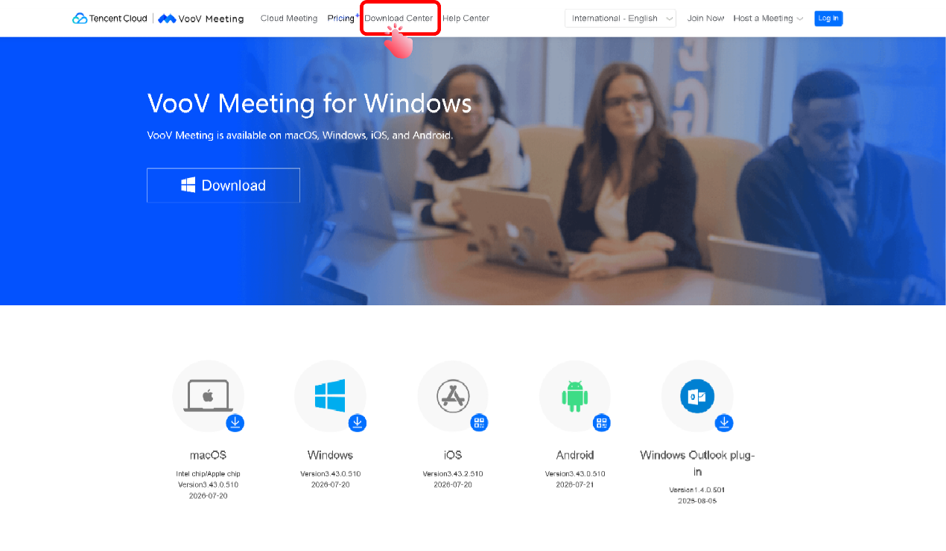
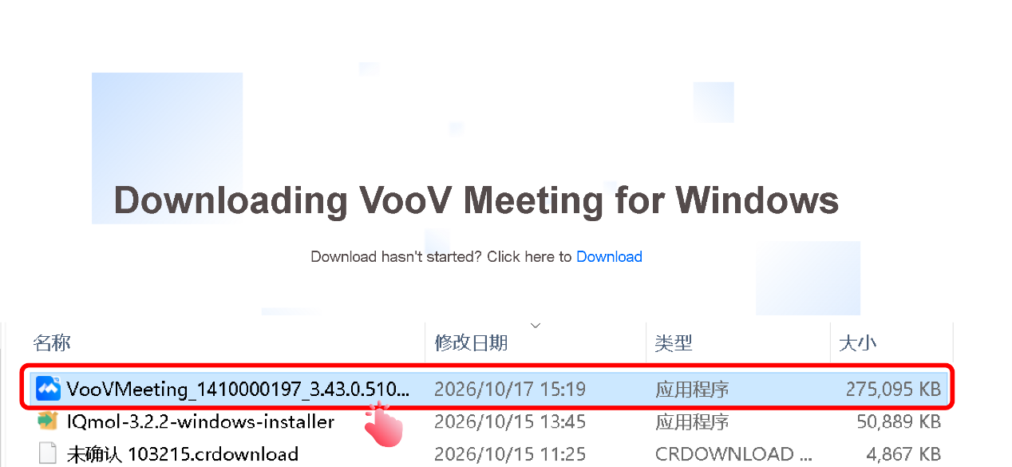

Step2: Install VooV Meeting
1. Double-click the downloaded installer file.
2. Accept the user agreement and click Install Now.
3. Wait for installation complete.
4. Click Launch VooV Meeting to open the software.
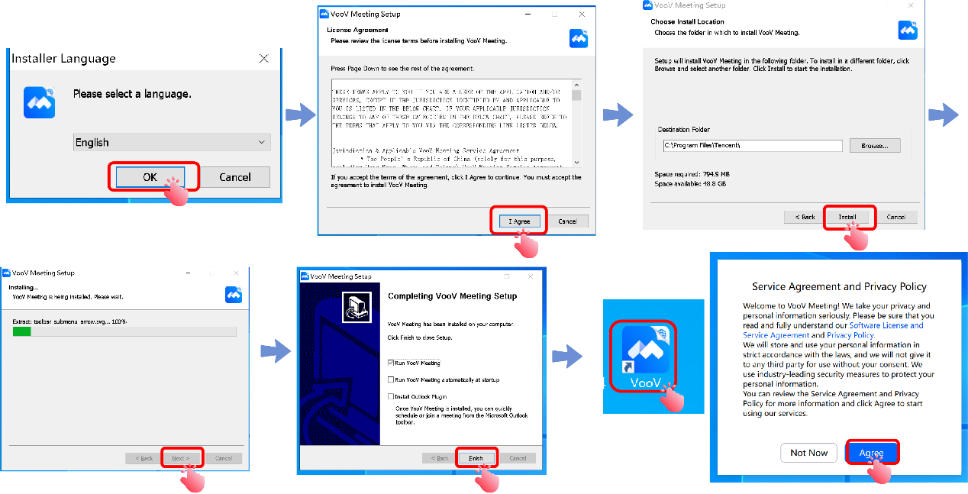

Step3: Register your VooV account (Oversea network required)
Important: Please register under overseas network. Mainland China IP will require mobile phone binding.
1. Open VooV, click Sign up.
Choose one registration method:
Option A: Continue with Google
Option B: Continue with Apple
Option C: Register with your email: enter your email, set password, verify via email code.
2. Fill in your display name for meeting.
3. Complete registration.
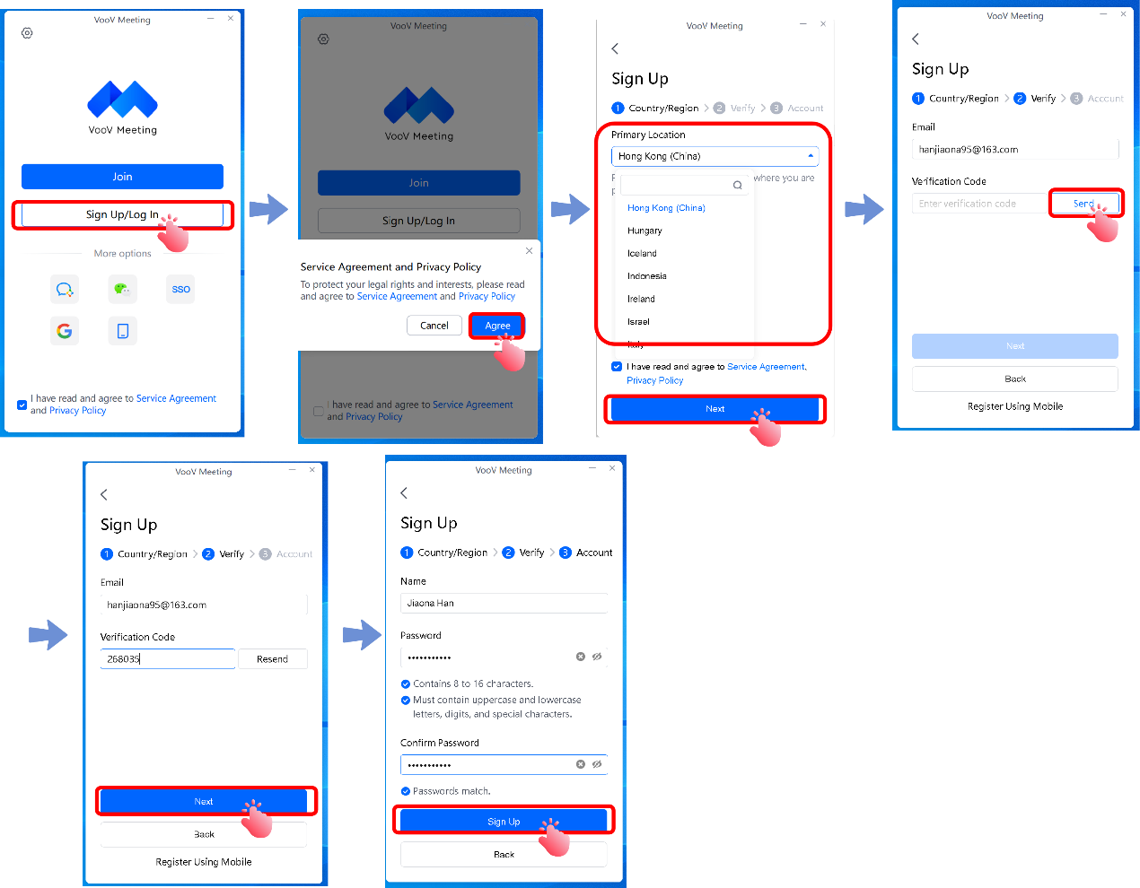

Step 4: Log in to VooV Meeting and join the meeting
1. Open the VooV Meeting client
2. Select the login method you used during registration:
a) Email account: Enter your email and password, then click Sign In
b) Google/Apple: Click the corresponding icon to log in instantly
3. On first login, grant software permissions: allow microphone and camera access
